|  |  |  |
| --- | --- | --- |
| Setpoint | | |
| **deg F** | .01 degC | **hex** |
| **160** | 7111 | **1B C7** |
| **150** | 6555 | **19 9B** |
| **140** | 6000 | **17 70** |
| **130** | 5444 | **15 44** |
| **125** | 5166 | **14 2E** |
| **120** | 4888 | **13 18** |
| **110** | 4333 | **10 ED** |
| **100** | 3777 | **0E C1** |
| **90** | 3222 | **0C 96** |
| **80** | 2666 | **0A 6A** |
| **70** | 2111 | **08 3F** |
| **60** | 1555 | **06 13** |
|  |  |  |

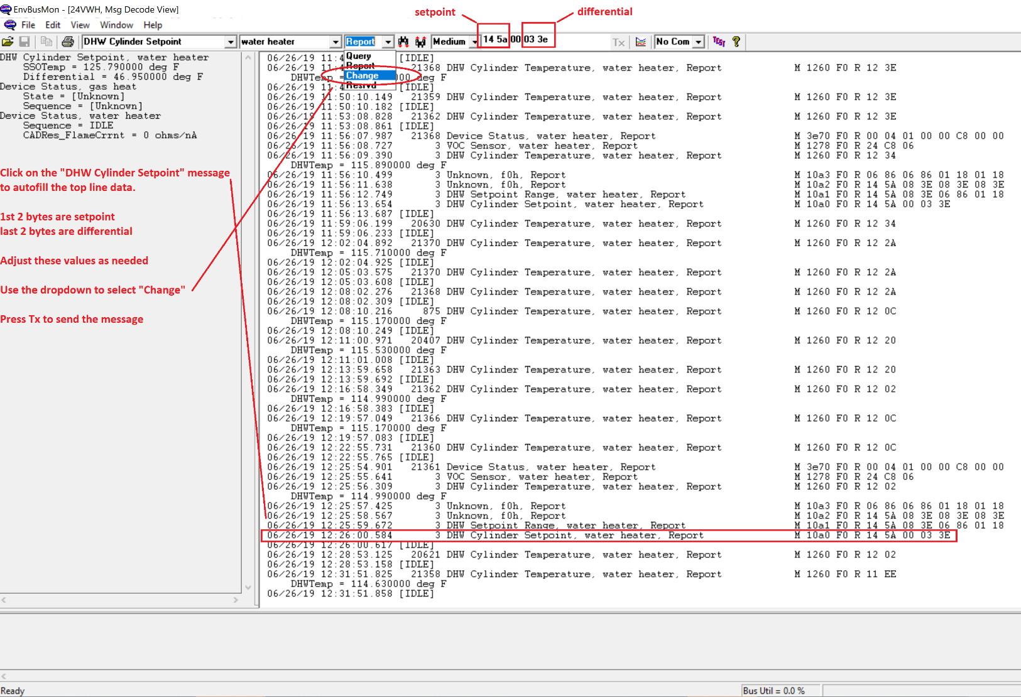

|  |  |  |
| --- | --- | --- |
| Differential | | |
| **deg F** | .01 degC | **hex** |
| **20** | 1111 | **04 57** |
| **19** | 1055 | **04 1F** |
| **18** | 1000 | **03 E8** |
| **17** | 944 | **03 B0** |
| **16** | 888 | **03 78** |
| **15** | 833 | **03 41** |
| **14** | 777 | **03 09** |
| **13** | 722 | **02 D2** |
| **12** | 666 | **02 9A** |
| **11** | 611 | **02 63** |
| **10** | 555 | **02 2B** |
| **9** | 500 | **01 F4** |
| **8** | 444 | **01 BC** |
| **7** | 388 | **01 84** |
| **6** | 333 | **01 4D** |
| **5** | 277 | **01 15** |

DHW Cylinder Setpoint contains setpoint and differential encoded in hex in .01 degC units.

Both setpoint and differential must be set together.

1st 2 bytes are setpoint, in the example above it is 14 5a = 0x145A = 5210 = 52.1 degC = 125.78 degF

Last 2 bytes are differential, in the example above it is 03 3e = 0x33E = 830 = 8.3 degC = 14.94 degF

A table of setpoints and differentials are to the right for quick reference.

Note that BusMonitor incorrectly decodes differential by applying an extra 32degF to the conversion.

Above, the differential is displayed as 46.95degF, which corresponds to 46.95 – 32 = 14.95 degF